**JAVASCRIPT ASSIGNMENT**

1. **Prompt the user his/her full name.** **form initials using the first characters of the first and last name.** **popup the initials.**

**CODE:**

**//SCRIPT.JS**

//create a function with name

function getValue() {

var initials;

//using prompt the user his/her full name

var name = prompt("Enter your name : ", "your name here");

document.write("You have entered : " + name);

//form initials using the first characters of the first and last name.

var names = name.split(' ');

initials = names[0].substring(0, 1).toUpperCase();

if (names.length > 1) {

initials += names[names.length - 1].substring(0, 1).toUpperCase();

}

//popup the initials

alert(initials);

}

<!--name.html-->

<html>

<head>

<!--adding javascript file to the html file-->

<script src="script.js">

</script>

</head>

<body>

<p> click the following button </p>

<form>

<!--input-->

<input type = "button" value = "Click Me" onclick = "getValue();" />

</form>

</body>

</html>

OUTPUT 1:

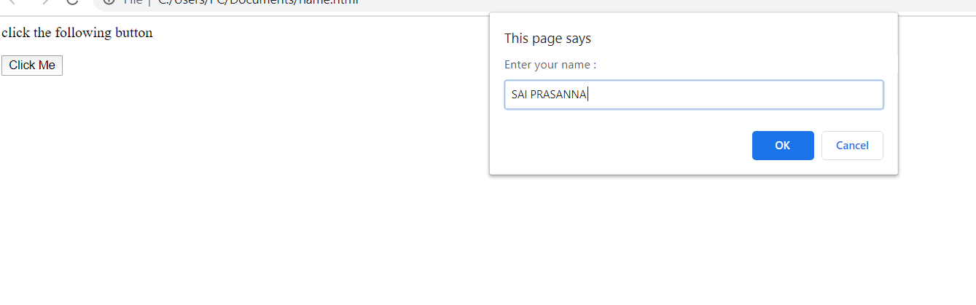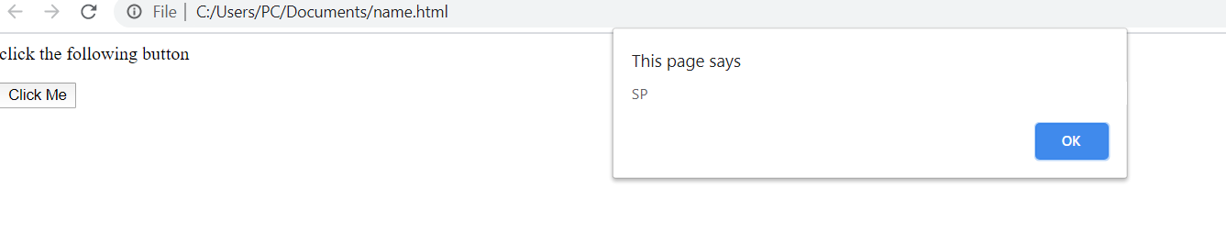 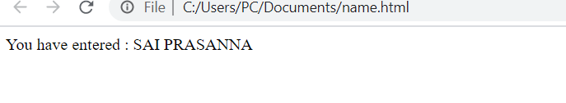

1. **write javascript function for generate random number between 0 and 9.**

**Code:**

**<!--Random.html-->**

<html>

<head>

//write javascript function for generate random number between 0 and 9.

<script type="text/javascript">

function getRandom(){

var min=0;

var max=9;

var random = Math.floor(Math.random() * (+max - +min)) + +min;

document.write("Random Number Generated : " + random );

}

</script>

</head>

<body>

<p>Click the button to display a random number.</p>

<!--input-->

<input type="button" value="TryIt" onclick="getRandom();"/>

</body>

</html>

**Output :**

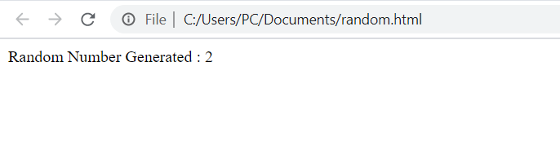

1. **generate electicity bill**

<!DOCTYPE html>

<html>

<body>

<h2>Electricity Bill Generation</h2>

<button onclick="electricityBill()">Click</button>

<p id="demo"></p>

<script>

//logic for electricity bill

function electricityBill() {

var billpay;

var units=prompt("Enter the units:",50);

var billno = prompt("Enter the bill no:",123);

var creditcardno = prompt("enter the credit card number:",13456789);

var date = new Date();

var day=prompt("enter date :",date);

if(date.getDate()>15 && date.getDate()<32){

var remdays=date.getDate()-15;

if( units<100){

billpay= units*1.20+remdays*50;

}

else if( units<300){

billpay=100*1.20+( units-100)*2+remdays*50;

}

else if( units>300){

billpay=100*1.20+200 *2+( units-300)*3+remdays*50;

}

else{

}

}

else{

if( units<100){

billpay= units*1.20;

}

else if( units<300){

billpay=100*1.20+( units-100)*2;

}

else if( units>300){

billpay=100*1.20+200 *2+( units-300)*3;

}

else{

}

}

document.getElementById("demo").innerHTML= billpay;

}

</script>

</body>

</html>

**Output :**

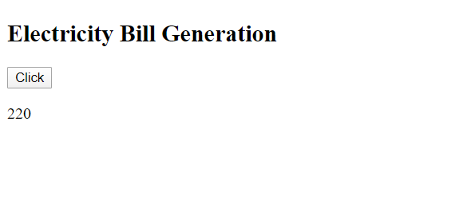

1. **calculation of factorial for given number.**

Code:

//script1.js

function calculateFact(){

var num = parseInt(window.prompt("Enter a number"));

if( isNaN(num) ){

alert( " Enter valid number " );

return;

}

var factorial = findingFact(num);

}

function findingFact(num ){

var i;

var fact = 1;

for( i = 1; i <= num; i++ ){

fact = fact * i;

}

document.write("Factorial of a given number is :",fact);

}

<!---factorial.html-->

<html>

<head>

<script src="script2.js">

</head>

<body>

<h4> Factorial of Number using JavaScript </h4>

<button onclick="calculateFact()">factorial calculation</button>

<button onclick="closeWin()">Close the window </button>

</body>

</html>

Output 1:

